Conditional indexing
a(k), if k is a conditional statement, extracts a where the condition is met.
x=1:10
x(x%2==0) means
2 4 6 8 10

For an audio signal, the time information is retained.
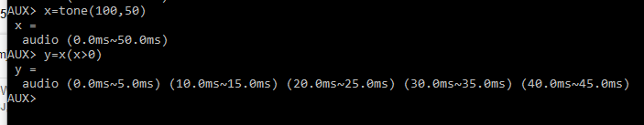
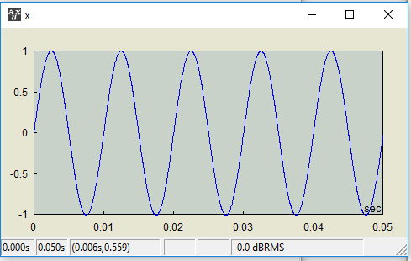
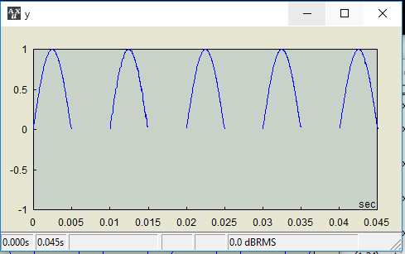
The conditional statement k may involve a different variable. It still evaluates the statement and generates the index array satisfying the condition.
ind=1:10
sq=(1:10)^2
sq(ind%2==0) is 4 16 36 64 100
alternatively,
sq((1:10)%2==0) is the same

Conditional indexing used for a 2-D array extracts the elements satisfying the condition AND the index for the other dimension. For example,
x=(1:24).matrix(6)
x(:,2) x((1:end)%2==0, 2)
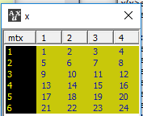

If the conditional indexing involves self, be careful
x(condition of x),
as is, “ungroups” x, i.e., it makes the 2D object an 1D object, because the matrix form will not be retained after evaluating the condition. For example,
x=randperm(100).group(10) // x is 2D
x(x>50) // this will be 1D, just a serialized vector of x that exceeds 50

But note that
x(condition of x) = expression with the replicator (..)
simply replaces the values of items satisfying the condition, therefore, x maintaining 2D, as long as it is permitted.

If the conditional indexing involves self and 2D, it gets crazy. For example,
x(x>10,3) might be interpreted as extract elements greater than 10 AND that appear in the third column. This is a problematic logic, the statement x>10 does not have to be the first indexing and this may cause a conflict in the code—i.e., the index statement in the first position for 2D is processed in the way that is not compatible with the statement x>10, which is blind for 2D processing. Therefore, this syntax shouldn’t be allowed. However, this syntax shouldn’t be blocked with an exception because 1) in rare cases the user might need it, and 2) it’s not absolutely clear to define “self-conditioning”—for example, if a is a copy of x, should x(a>10,3) treated as a self-conditioning case? So, the syntax is allowed. The rule is unambiguous (this means that the above possible unofficial interpretation was only a dream, not practical) and the user should exercise caution when using this.
Anyhow, what is the meaning of x(x>10,3)? For the first index, it is the index array satisfying x>10, that is
11 12 13 … 24
With the second index argument, the actual index array would be
43 47 50 …
Therefore, it would be an out-of-range index error.

